Class, Roots

1. Draw diagrams of roots problems, multiple roots, no root. Describe process where you want to solve for RHS and LHS of equation such that they are equal (e.g., equal to zero).

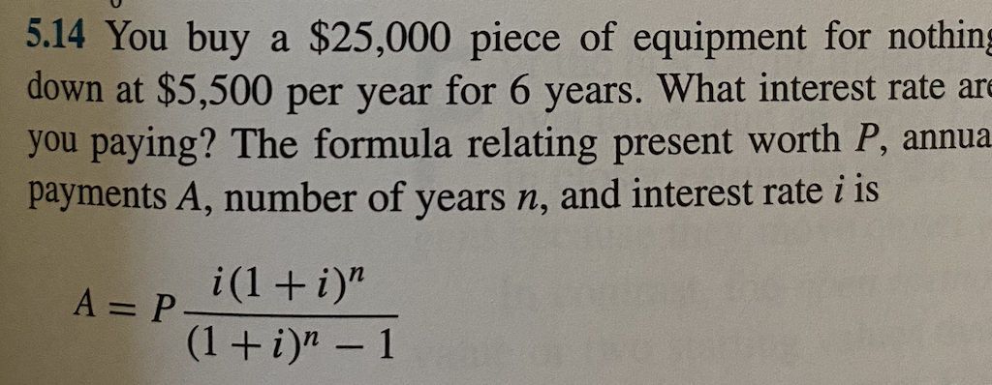

1. Functions: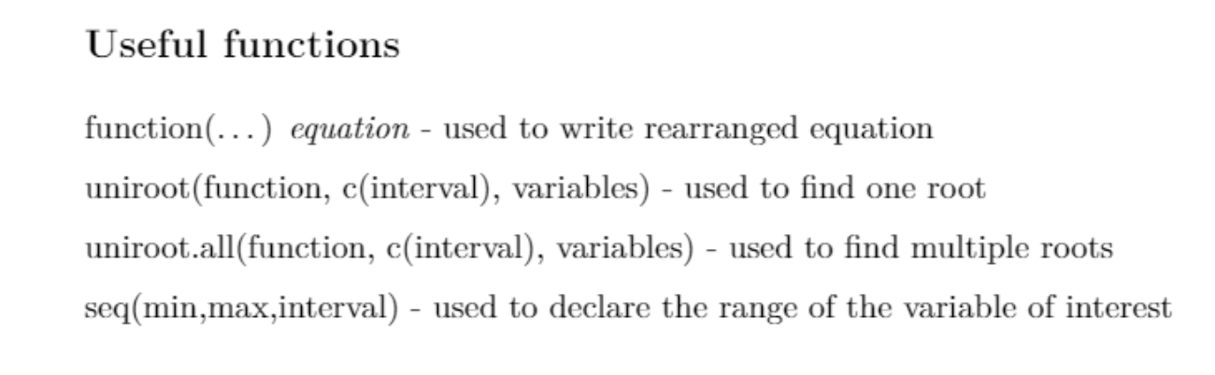
2. Show trial and error, follow by using uniroot.
3. Go through example, pay attention to lower and upper end to bracket the root. Thus, plot helps show there is indeed a root!

